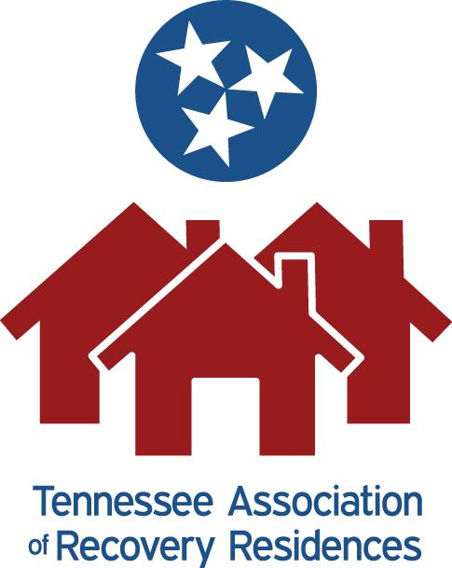

Tennessee Association of Recovery Residences

Affiliate Application Packet

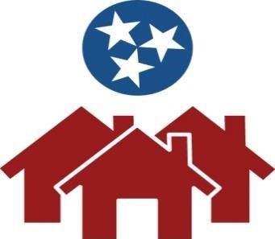

Tennessee Alliance of Recovery Residences

Action Steps to Become Certified

Any communication should be mailed to:

TENNESSEE ALLIANCE OF RECOVERY RESIDENCES
PO Box 120114
Nashville, TN 37212

Steps to Certification

1. Submit Application Packet and Payment
Submit the application through the website or email to tnarrtennessee@gmail.com or by mail to the address above with the $250 application fee by check or money order.

2.When the application is submitted what will happen?
When the application is submitted you will be contacted by phone or e-mail. Requests will be made per the “Paperwork File Checklist” for all documentation that impacts the client for TN-ARR committee review.

The Paperwork needed is outlined in the “Paperwork File Checklist”
Please be sure the language in said paperwork is Social Model Language (Explained in Paperwork File Checklist). Social Model Language is client-friendly, non-authoritarian, and voluntary.
Your paperwork will be reviewed by a committee of peers trained in the NARR standards and Ethics.
You will be notified of suggestions the committee recommends if needed. You may have an Operator or Leadership Committee member who is already certified available to you to help with this process.

To be compliant with Certification Standards, Social Model, and NARR standards and Ethics can be an extensive and tough process, therefore, Follow-up emails or phone calls may be needed for clarification on specific information. During this process TN-ARR may also refer applicants to various training modules for education/clarification.

Once the Paperwork review process has been completed TN-ARR will email the provider with the results.

After suggested changes have been made by TN-ARR it is up to the potential affiliate to make said changes and resubmit their paperwork. How quickly these changes are made and resubmitted will determine the length of the Certification process.

3. Checklist and Paperwork Completion
When the Paperwork File Check List is approved by the committee, WE will contact our on-site assessors.
The assessors will contact the applicant and schedule a time for an on-site assessment.

On-site assessments are conducted by trained TN-ARR peers designated by TN-ARR to conduct the on-site assessments.

Please remember our assessors are not State or Codes affiliated. They are peers and willing to help with the on-site assessment process.

Please remember that the on-site assessors have a schedule, and they will contact YOU to schedule your assessment.

4, Onsite Assessment
Before your On-Site Assessment you should review the “On-Site Assessment Checklist” and make the necessary changes to your environment.

Please be sure you and the assessor have signed the on-site assessment form at the time of the visit.

During the assessment any deficits, concerns and/or recommendations will be discussed, and solutions suggested. Solutions may include confirmation pictures or a site revisit in order to clarify necessary changes have been made. Extra charges may apply for environments requiring more than one On-Site Assessment.

When the On-Site assessment is completed and approved a copy of the on-site assessment will be put in your file.

Pending Classification- If you receive a pending classification on your on-site assessment you will be given ninety (90) days to complete the Assessor’s suggestions. In some cases, a photograph may be acceptable. If it is necessary for an Assessor to revisit your environment, you will be charged a fee under the current State and Federal Guidelines for travel time, mileage, and per diem costs.

Not Passed/Failed Classification-If you are given a Not Passed and/or Fail classification on your on-site assessment, it will be one (1) year before you become eligible to submit a new Application at current rates.

If you are located more than one hundred (100) miles from the Assessor’s place of origin travel time, mileage, and per diem costs will be billed at current State and Federal Guidelines.

TN-ARR’s long-term goal is to have assessors Statewide.

5. How much does Certification cost?
Annual Certification is based on bed capacity per environment.

Current price range:
Recovery Residence with 1-8 beds $300 per year
Recovery Residence with 9-20 beds $400 per year
Recovery Residence with 21-30 beds $500 per year
Recovery Residence with 31-40 beds $600 per year
Recovery Residence with 41-50 beds $700 per year
Recovery Residence with 60 + beds $800 per year

This is the cost for Certification and the maintenance of that Certification on an annual basis. This fee is to be paid after completion of the Certification process AND annually during the renewal or your existing Certification.

These costs are subject to change.

Potential added cost: If you have not completed the paperwork and passed the Standards and on-site assessment within 6 months you will need to resubmit a new application with another $250.00 application fee.

6. Invoice and Payment
When the previous steps are completed, and your application/recertification payment is rendered you will be notified that you have been approved to be certified/recertified.

An invoice will be sent to you by the Treasurer to be paid immediately.

It is the Owner/ Operator’s responsibility to reach out to TN-ARR for annual renewal including any additions or changes to their environments.

7. Annual Recertification
All environments must recertify annually. TN-ARR will send out a reminder prior to recertification being due until proper dues are rendered. It is the owner/operator’s responsibility to renew their dues and to contact TN-ARR yearly for on-site assessment.

A certification will be presented or emailed to the environment, and they will be listed on TNARR website and the NARR website. Your Certificate should be posted in the entranceway of your environment.

NOTE: Certification is all or nothing. An owner/operator must certify all eligible recovery residences, meaning an environment cannot certify a “flagship” property while operating their remaining recovery homes outside of the TN-ARR standards. If an environment operates other types of properties such as Treatment or IOP the “all or none” rule does not apply to the houses that are not recovery residences. If an owner/operator operates an intensive residential treatment program the licensed treatment center would not have to be certified as a recovery residence if it does not advertise itself as such.

Tennessee Association of Recovery Residences
Affiliate Benefits

- The ability to have a voice into decisions affecting recovery residences in Tennessee with a Certification body that is recognized by the state of TN and nationally.
- Increased credibility for your Recovery Residence due to meeting a high level of standards and ethics. This certification enables you to accept referrals and be posted on the state list and all municipalities under the Safe Act being implemented June 2022.
- The ability to be part of a Mentorship program with long-time certified residences aiding and sharing their knowledge and expertise, and experiences.
- An enlarged free referral base from the TN-ARR web site, referrals from TN-ARR peers, and the recovery community network that TN-ARR interacts with through conferences, publications, and mailings.
- Widespread site representation at no cost by having your brochures available at major conferences where TN-ARR has an exhibit booth.
- Staying abreast of current trends, laws, funding resources, and issues affecting recovery residences.
- Opportunity to be a part of an active, knowledgeable network, as well as enjoy fellowship with Experienced Peers in the field.

Tennessee Association of Recovery Residences
Affiliate Requirements

The Tennessee Association of Recovery Residences will identify your house as a healthy, safe, ethical environment. The Tennessee Association of Recovery Residences is an affiliate association for quality Recovery Residences in the state of TN. Once you have met all requirements on the File Checklist your residence(s) will be placed on the Certification list, a national Registry, and on our website.

Requirements:

- Your recovery residence is a “Social Model’* , substance use free environment, and has a policy recognizing Medically Assisted Recovery (MAR).
- Your recovery residence accepts and accommodates persons recovering from addiction
with/without co-occurring mental health disorders.
- Your recovery residence allows applicants to voluntarily commit to a substance free recovery pathway.
- Certification Applicants must sign and abide by the Tennessee Association of Recovery Residences Code of Ethics found in the File Checklist Compendium .
- Attend Tennessee Association of Recovery Residences Monthly meetings at least once Quarterly (Attendance is recorded).
- Pass an On-Site Physical Assessment and continue to maintain clean and organized residences as representatives of TN-ARR may randomly visit..
- Your Recovery Residence(s) paperwork has been reviewed and approved by the TN-ARR Certification Committee.
- Attend Trainings and Educational events advised by TN-ARR that support Recovery Housing Standards and Ethics.
- *Social Model is defined as a client friendly, self-voluntary, non-authoritarian environment governed by peers.

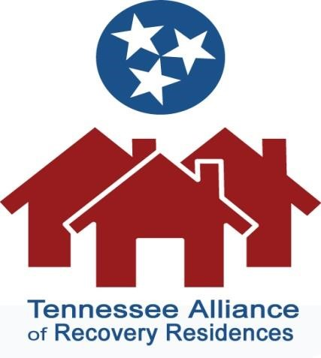

Tennessee Alliance of Recovery Residences Annual Contributions
Initial Contributions will be prorated and billed upon completion of Certification. Annual Contributions are then payable January 1st each year. Once the Annual Contributions are paid, you will be scheduled for your Renewal On-Site Assessment.
Each Recovery Residence seeking Certification or Recertification by TN‐ARR shall pay Annual Contributions based on the number of beds provided according to the following schedule:
Affiliate Annual Contributions
Recovery Residence with 1‐8 beds  Recovery Residence with 9-20 beds  Recovery Residence with 21-30 beds  Recovery Residence with 31-40 beds  Recovery Residence with 41-59 beds  Recovery Residence with 60+ beds | $300 year  $400 year  $500 year  $600 year  $700 year  $800 year

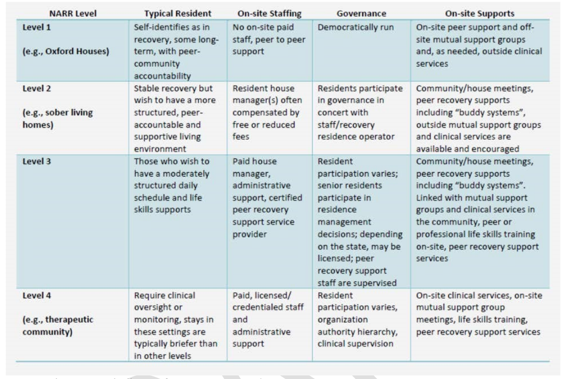

Tennessee Association of Recovery Residences Affiliate Application

If you need more space for answers to application questions, please feel free to use a separate sheet. Application forms may be emailed to tnarrtennessee@gmail.com. Application material sent by postal or express mail should be addressed to:

Tennessee Association of Recovery Residences
P.O. Box 120114
Nashville, TN 37224

Section 1: Residence Information
(Check those that apply)

_____ New Affiliate Total Number of Beds across ALL Residences:_______________
_____ Existing Affiliate

Name of Recovery Residence/Potential Affiliate: __________________________________________________________

Recovery Residence Level (as defined by the NARR levels displayed above): _____________________

City of Recovery Residence: _________________________________State: _____________________Zip:________________
Website address: __________________________________________
Residence is: (check those that apply)

____Owned by affiliate
____ Leased from third party

Year founded: _____________________ Type of Structure: (Check all that apply)
Number of Residences:_______ ____ Single family home
____ Apartment Building
____ One or more apartment units
____ Condominium unit
____ Duplex or triplex
Other: ____________________________________
Affiliate Application
Tennessee Association of Recovery Residences
Serving: (Check all that apply)
_____ Men _____ Co-ed
_____Women _____ Men w/children
_____Women w/children

Is Residence approved by TDOC (Tennessee Department of Corrections)? Yes ____ No____

Section II: Affiliate Information

Owner/Operator’s name: _________________________________________________________

Type of Organization: (check all that apply)

____Corporation ____ Nonprofit Organization
____ Partnership ____ Nonprofit-Other
____ Limited Liability Company (LLC) ____ Unincorporated Entity Other _______________________
Owner/Operator’s address: __________________________________________________________________________________

City: ________________________________________ State: ______________________________ Zip: _________________________

Owner/Operator’s Phone Number: __________________________________

Owner/Operator’s Email: _________________________________________

Does applicant own or operate a licensed drug and alcohol facility? ___Yes ____ No
If yes, name the licensed program or facility: _______________________________________________________
Number of Recovery Residences operated by this organization: _________________________________________

Affiliate Application
Tennessee Association of Recovery Residences

Are you willing to fully participate in TN-ARR activities? _____Yes _____No
Have you read and understood the requirements? _____Yes _____No

Have you reviewed the NARR recovery residence 3.0 standards-compendium? (Can be found at NARRonline.org) _____Yes _____No
Have you reviewed and signed the Code of Ethics? _____Yes _____No

Section III: Contact Information

Primary Contact for Potential Affiliate:

Name: _______________________________________________ Position/Title: _________________________________________

Phone Number: _____________________________________ Contact email: _________________________________________

Manager, senior resident or responsible person for this residence:

Name: _______________________________________________ Position/Title: _________________________________________

Phone Number: ____________________________________ Contact email: __________________________________________

Section IV: Applicant Signature

I certify that this application is supported by the applicant organization named above, and that it has delegated to me the authority to submit this application on its behalf.

Print Name: _________________________________________________ Date: ______________________________

Signature: __________________________________________________________

Tennessee Association of Recovery Residences
Code of Ethics

TN-ARR affiliates will commit to conducting their business honestly and ethically wherever we operate in the State.
We strive to constantly improve the quality of our services and operations and create a reputation of honesty, fairness, respect, integrity, responsibility, trust, and sound business ethics.
We are dedicated to the belief that there is dignity and worth in all human beings. It cannot be emphasized enough that illegal or unethical conduct on the part of affiliates tarnishes the image of TN-ARR.
TN-ARR affiliates do not compromise their principles for short-term advantage. The ethical performance of this organization is the sum of the ethics of our Owner/Operators.
All are expected to adhere to high standards of professional and personal integrity.

Personal Statement
If a Recovery Residence owner or manager is found to have violated any of the above code of ethics of the Tennessee Association of Recovery Residences after receiving appropriate notice and an opportunity to be heard, such violation may subject restrictions of the individual for review and penalties. These penalties may include, but are not limited to, public reprimand, suspension, or revocation of membership. This action does not curtail any of the other rights and remedies of the parties to redress, nor shall a determination of a violation rise to the level of proof as if the matter were heard in a court of competent jurisdiction.
My signature below indicates my agreement to abide by the code of ethics.
Name: _________________________________________________________________________ Date: _________________________________
Name of Potential Affiliate: ______________________________________________ Date: _________________________________
Signature: _________________________________________________________________________________________________________________
List of Potential Residences

Residence address:
Street and house Number: _______________________________________________
City: ________________________
State: ________ Zip Code: _____________
Number of resident beds: __________
Residence Level in accordance with NARR levels (graph above for reference): _______
Residence address:
Street and house Number: _______________________________________________
City: ________________________
State: ________ Zip Code: _____________
Number of resident beds: __________
Residence Level in accordance with NARR levels (graph above for reference): _______
Residence address:
Street and house Number: _______________________________________________
City: ________________________
State: ________ Zip Code: _____________
Number of resident beds: __________
Residence Level in accordance with NARR levels (graph above for reference): _______
Residence address:
Street and house Number: _______________________________________________
City: ________________________
State: ________ Zip Code: _____________
Number of resident beds: __________
Residence Level in accordance with NARR levels (graph above for reference): _______
Residence address:
Street and house Number: _______________________________________________
City: ________________________
State: ________ Zip Code: _____________
Number of resident beds: __________
Residence Level in accordance with NARR levels (graph above for reference): _______
Residence address:
Street and house Number: _______________________________________________
City: ________________________
State: ________ Zip Code: _____________
Number of resident beds: __________
Residence Level in accordance with NARR levels (graph above for reference): _______
Residence address:
Street and house Number: _______________________________________________
City: ________________________
State: ________ Zip Code: _____________
Number of resident beds: __________
Residence Level in accordance with NARR levels (graph above for reference): _______

Residence address:
Street and house Number: _______________________________________________
City: ________________________
State: ________ Zip Code: _____________
Number of resident beds: __________
Residence Level in accordance with NARR levels (graph above for reference): _______
Residence address:
Street and house Number: _______________________________________________
City: ________________________
State: ________ Zip Code: _____________
Number of resident beds: __________
Residence Level in accordance with NARR levels (graph above for reference): _______
Residence address:
Street and house Number: _______________________________________________
City: ________________________
State: ________ Zip Code: _____________
Number of resident beds: __________
Residence Level in accordance with NARR levels (graph above for reference): _______
Residence address:
Street and house Number: _______________________________________________
City: ________________________
State: ________ Zip Code: _____________
Number of resident beds: __________
Residence Level in accordance with NARR levels (graph above for reference): _______

Tennessee Alliance of Recovery Residences
Paperwork File checklist
“An alliance is a relationship among people, groups, or states that have joined together for mutual benefit or to achieve some common purpose, whether or not explicit agreement has been worked out among them”

TN-ARR Paperwork File CHECKLIST

All documentation on this page must be submitted to TN-ARR via the website or email at Tnarrtennessee@gmail.com , and the application fee must be paid before the paperwork and inspection process will begin.
REQUIREMENTS FOR CERTIFIED AFFILIATE STATUS

_________ Fill out Affiliate Application Packet

_________ | Review the NARR 3.0 Standards and Code of Ethics. (Can be found at Narronline.org)
_________ | Vision Statement- A vision statement is a statement that creates a mental image of the objective an organization wishes to achieve. This should be in the form of a typed Word document that corresponds with TN-ARR/NARR’s core principles and Social Model.
_________ | Mission Statement -Defines the company/organization’s business objectives, and its approach to reach those objectives. This should be in the form of a typed Word document that corresponds with TN-ARR/NARR’s core principles and Social Model.
_________ | Codes Compliance- This is a word document from the city/county or the owner/operator stating that the residence is in compliance with Codes and Zoning in its specific area.
_________ | Fire Safety Compliance- This is a letter from the owner/operator stating that their residence is compliant with the fire codes of their area and has spoken to their local fire station. NEW CONSTRUCTION HOMES WILL NEED PROOF OF FIRE MARSHALL INSPECTION.

_________ Letter from HOA, if applicable
_________ Letter from Landlord, if applicable
_________ COI (Certificate of Insurance)
_________ Organization Origination Document SUCH as LLC, S-Corp, or 501-C3 documents

RESIDENT PAPERWORK
__________ All paperwork (i.e Entrance paperwork, House Guidelines, etc.) that the resident will be presented needs to be submitted using Social Model Language. This is all paperwork that impacts the resident from the time of their first contact to their transition out of the environment.
(Social Model language is client-friendly, non-authoritarian, and self-voluntary) Examples: “I agree”, “I commit to”, “I am willing to”, etc.
__________ Paperwork that includes the financial responsibilities of the resident or guarantor.
__________ | Word Document explaining substance testing procedures.
__________ | Word document explaining Medication Procedures.
__________ | Explanation of MAR (Medically Assisted Recovery) Procedure. Examples can be found at narronline.org

If you have questions regarding these items, please refer to the File Checklist Compendium as many of these subjects have been elaborated on in the Compendium including NARR 3.0 standards and Ethics.

Tennessee Alliance of Recovery Residences
File checklist Compendium

“An alliance is a relationship among people, groups, or states that have joined together for mutual benefit or to achieve some common purpose, whether or not explicit agreement has been worked out among them”

- REQUIREMENTS FOR AFFILIATE STATUS

- Recommended NARR (National Alliance for Recovery Residences) compliance. Since TN-ARR is an affiliate of NARR, you will be encouraged to follow NARR recommendations. We suggest you review the NARR website for the national quality standards, code of ethics and further understanding at https://narronline.org.

- _____ Have you reviewed the National Quality Standards and Code of Ethics? NARR, the National Alliance for Recovery Residences, has established a national standard that outlines the variety of recovery-oriented housing and services and differentiates four different types, known as “levels” or “levels of support.” Please view the below link for the code of ethics.
https://narronline.org/wp-content/uploads/2017/10/NARR_ethics_code_amended_10-2017.pdf

- _____ Vision Statement. A written statement that corresponds with NARR’s (National Alliance of Recovery Residences) core principles. A vision statement acts as a guidepost for the future of your recovery residence. It is inspiring and hopeful. You should ask yourself - What problem are we trying to solve? Where are we headed? What do I want for my residence and its future residents?

- _____ Mission. A written statement that corresponds with NARR’s (National Alliance of Recovery Residences) core principles. A mission is a brief explanation of your residence’s reason for existence. It should define your residence’s purpose and intention. The mission should support your Vision Statement and communicate purpose and direction for your residence. Ask yourself – What is my residence’s purpose? Why does my residence exist? Since TN-ARR is an affiliate of NARR, you will be encouraged to follow NARR recommendations. We
suggest you review the NARR website at https://narronline.org/ for further review and understanding.

For further reading to better understand recovery residences review the below article - https://www.addictionpro.com/article/new-understanding-recovery-residences

- Tennessee Law
As a matter of State Law, the SAFE Act (Stopping Addiction and Fostering Excellence) has been passed. To read about how the SAFE ACT HOUSE BILL came to fruition and its background please review the following article. https://tnhousegop.org/representative-curcio-files-legislation-to-improve-quality-of-care-for-tennesseans-battling-addiction/

SAFE ACT, House Bill 215 by Curcio and Senate Bill 207 by Haile. See the link below of further compliance. https://www.capitol.tn.gov/Bills/112/Bill/SB0207.pdf

For further information on the Tennessee Landlord and Tenant Act review the below website.
https://www.tn.gov/health/cedep/environmental/healthy-homes/hh/renters.html

For the full Tennessee Code Annotated Title 66 Chapter 28 - Uniform Residential Landlord and Tenant Act review the below.
https://www.tennfairhousing.org/sites/tennfairhousing.org/files/2014URLTA.pdf

See the below written example:
The Resident shall occupy the premises in accordance with all laws and regulations pertaining thereto. Resident shall return the premises at the termination of residency in the same condition as received, ordinary wear and tear.
This agreement shall terminate in the event that the premises are destroyed, other than negligence of the Resident, or upon taking of the property under legal authority of eminent domain.
Resident at ________is pursuant to Tennessee Code Annotated 66-28-102(c)(1), which states residence at an institution, public or private if incidental to detention or the provision of medical, geriatric, educational, counseling, religious, or similar service is not subject to the provision of the Uniform Residential Landlord and Tenant Act of Tennessee. In other words, this agreement is not a lease and notice is not required to discharge a resident for violation of environmental guidelines.

_____ Report on municipalities (zones and codes) compliance. This is a written report from codes/written owner statement of compliance and understanding.

- Community Based Best Practices. A best practice (as it relates to recovery
residences) is a way of doing things that has been generally accepted as suitable to any alternatives because it produces results that are safe and ethical to those achieved by other means or because it has become a standard way of doing things (e.g., a standard way of complying with legal, ethical and national requirements and standards). The following best practices maintain the health and safety of the residents, the neighborhood, and the larger community. NARR/TN-ARR established that these standards provide guidance on “good neighbor” policies to promote positive community involvement in residential neighborhoods.

_____ Fire Marshall TN-ARR suggests you visit your local firehouse to inform them of who you are and where you are.
It is our experience that they are willing to help and are usually very supportive
appreciative of the effort

- Existing builds- Please provide a written letter of compliance by the owner for the following fire safety points: smoke detectors that meet the minimum city/county requirements, fire extinguishers that meet city/county requirements, evacuation plans posted, etc...
- New builds- please provide site fire inspection approved report or permit.
_____ Visit your local police precinct - TN-ARR suggests that you visit your local Police Precinct. Here is a link to help guide you to your local police in your neighborhood.

“Each police precinct has a community coordinator sergeant available to serve the needs of you and your neighborhood. Get to know your police department, we are here for you!” -by the Social Media Manager of the Police Department
Please visit the below website for further information.
https://www.nashville.gov/Police-Department/Community-Services.aspx
_____ Connect with your local and State Legislature- TN-ARR suggests that you
familiarize yourself and connect with your local and State legislatures. This
includes: Federal, State and Local Representatives that represent you. Our intention is
to be transparent and to be contributing parts of our communities. This is yet another
step in helping recognize recovery residences as desirable and essential.
Here is a link to help locate your legislature.
https://openstates.org/find_your_legislator/
_____ Letter from HOA, if applicable
_____ Letter from Landlord, if applicable
_____ COI (Certificate of Insurance)
_____ Organization Origination Document as LLC, S-Corp, or 501-C3. This provides
clarification that the residence is not a business but a home. The owner/manager is the business.
_____ CDC Infectious Disease Compliant (COVID-19). A best practice as it relates to infectious diseases. Please provide a written statement that you follow safety procedures as it relates to infectious diseases.
Here are helpful state/local and federal recommendations and information.
https://www.cdc.gov/coronavirus/2019-ncov/prevent-getting-sick/prevention.html
https://www.cdc.gov/coronavirus/2019-ncov/community/disinfecting-building-facility.html
https://covid19.tn.gov/

- RESIDENT PAPERWORK - BEST PRACTICES 3.0 STANDARDS
A best practice (as it relates to recovery residences) is a way of doing things that has been generally accepted as suitable to any alternatives because it produces results that are safe and ethical to those achieved by other means or because it has become a standard way of doing things (e.g., a standard way of complying with legal, ethical and national requirements and standards). The following best practices help to create a safe, ethical, and healthy living environment to initiate and sustain the recovery of its residents.
https://narronline.org/wp-content/uploads/2018/11/NARR_Standard_V.3.0_release_11-2018.pdf

_____ Style: Social Model – This model of recovery is operated by the residents and promotes a peer-operated residence oriented towards peer support, community living, and the practice of 12-step recovery principles.
TIP: steer clear of using language that is forceful such “as you will”, instead use “I will”, giving the resident the responsibility.
- The following article is a brief glimpse on the social model
https://www.ncbi.nlm.nih.gov/pmc/articles/PMC4220294/
- NARR supports this model and has some outlined information and guides for you. See the below link for further information and explanation.
https://narronline.org/wp-content/uploads/2014/06/Primer-on-Recovery-Residences-09-20-2012a.pdf
_____ Home Requirements – Guidelines for living in the residence. Resident’s responsibilities
_____ Financial Transparency Statement – Lets the resident know what to expect financially. This should be a documented procedure that can be found in your environment’s paperwork.
_____ Drug Screen Policy – what is your procedure – ex. how often? What will prompt a drug screen? What is the procedure if a drug screen is positive? TN-ARR recommends a Confirmation test. The resident chooses where to get it done and pays for the test. See the below policy for review.
See the attached document at the end of this checklist for the full drug policy published by NARR.

_____ Entrance and Exit Criteria Policy - What is your procedure? Think of this as writing a 3-part experience. It is a beginning – the entrance, the middle – includes house requirements, and evolution (exit).
Remember – Under State and Federal Law you cannot evict, discharge or “throw out”.
_____ Medication Management Policy – How are medications secure in your residence? Are they locked away? What medications are allowed onsite?
Federal law prohibits non-medical staff from dispensing medication.
_____ MAT Policy and Procedure - How do you manage and support MAT (Medication-assisted treatment) residents? Under FDA regulations you cannot discriminate against medically prescribed medications. https://narronline.org/wpcontent/uploads/2018/09/NARR_MAT_guide_for_state_agencies.pdf
https://narronline.org/wp-content/uploads/2019/03/NARR-C4-NCBH_MAR-RH-Brief.pdf

_____ Peer Driven – A program that is run by peer-to-peer, meaning there are house managers (on a similar level as the other residents) unpaid or paid, there should be peer run groups, house meetings, and active involvement of all the residents. No one person should sit on a higher ground than the rest of the community. The residence runs similar to “12 Step” meetings, remember the simple saying - “just one addict/alcoholic helping another”.
Review the following levels of support for a clearer understanding of your residence support level -http://tnarr.org/wp-content/uploads/2016/09/Recovery-Residence-Levels-of-Support.pdf
_____ Client Friendly – Language that puts the responsibility on the resident and wording that highlights empathy and understanding

MAKE SURE YOU WATCH FOR FORCEFUL LANGUAGE IN YOUR PAPERWORK.
For further information on TN-ARR please visit our website at http://tnarr.org/

- ONSITE SAFETY AND ENVIRONMENTAL ASSESSMENT (INSPECTION)

A copy of the onsite assessment form and what we look for can be found on our website at: http://tnarr.org/wp-content/uploads/2018/03/TNARRinspection2016pdf_New.pdf

Date: _______ Assessor__________________________
Approved ______ Needs upgrades ______ Not Approved ______
TN-ARR Meeting attendance (attendance taken at each meeting) : ___________________
Training (attendance taken at each meeting) _____________________________________
Committee__________________________________________________________________
Board Position_______________________________________________________________
Training_____________________________________________________________________

Comments: ___________________________________________________________________________________________________________________________________________________________________________________________________________________________________________________________________________________________________________________________________________________________________________________________________________________________________________________________________________________________________________________________________________________________________________________________________________________________________________________________________________________
Date: _________________________
Reviewer: ___________________

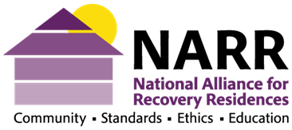
NARR Standards and Recommendations
Ethical Policies Regarding Drug Testing

Drug Testing, Confirmation Testing and Third-Party Payment

Definitions:
Point of care or screening test -​ Often referred to as a ‘test cup’. A test of urine, breath, saliva, hair or other body product samples performed onsite that typically checks for one or more classes of drug metabolites (not the drug itself). The results are not definitive until confirmed by a toxicology/confirmatory test.
Toxicology ​- ​A laboratory ​ test that definitively determines the approximate amount and type of drugs​ present in the sample.
Intent - ​Motivation for drug screening​.
Confirmation test ​- ​Conducting a second screening test is not a confirmation test. Instead, a medical laboratory test is used to confirm a screening test result, preferably conducted on the same sample used for the screening test. These are typically gas chromatography/mass spectrometry (GC/MS) or high-performance liquid chromatography (HPLC) tests that identify the specific substance and the amount present in the sample. Confirmation tests may be the only type of test result that is admissible in a court of law.
Third-Party payment​ -​ ​ A third party, most commonly an insurance company but may be anyone other than the person who received the service, pays the healthcare provider for services rendered.
Transparency ​- Full disclosure in all aspects of operation.
Sample collection protocol​ - An invariable method of preparing the drug test sample collection site, observing sample collection, and maintaining a sample chain of custody from collection to testing.
Person-driven recovery​ - A process of change through which individuals improve their health and wellness, live a self-directed life, and strive to reach their full potential. (SAMHSA)
IOP/ PHP - ​Abbreviations for Intensive Outpatient or Partial Hospitalization clinical settings.

Introduction
The intention to support recovery must always be the grounding ethical principle of any drug testing protocol. It is unethical to drug test for any other reason besides supporting recovery. High frequency of testing, applying clinical protocols in a non-clinical facility, and utilizing drug testing as a source of revenue generation might all be indicators of unethical drug testing.

Effective drug testing can be conducted in a variety of ways. However, an essential component is a consistent application of policy. Therefore, several variables should be considered when setting and implementing policy for drug testing and toxicology protocols - empowerment, accountability, and safety.

I. Policy Regarding Drug Testing

1. ​ ​​The purpose of drug testing and its frequency is to support residents’ recovery​.

Drug testing is a useful tool for initiating and celebrating recovery while promoting safe, alcohol and other drug-free recovery residences. There are four primary reasons a recovery residence operator utilizes a drug testing protocol:
- To support person-driven recovery
- To maintain a healthy recovery culture, supportive environment and community morale
- To foster individual and community accountability
- To document and celebrate progress

- When to drug test​
Commonly used protocols:

  - Upon entry - ​ An initial drug screen is conducted upon entry, even following transport​ directly from a treatment or institutional program.

  - For cause - A drug test is administered for observed unusual or risk-suggestive behavior.

  - Random - Randomly select a subset of all residents for regularly scheduled testing so that each person has an equal likelihood of being selected every time.

  - Designated - Every resident is tested when specified events occur, e.g, before leaving and upon return from passes, before program phase movement including transitioning out of the residence, moving into a privileged bedroom, accepting mentoring or other community leadership responsibilities, and getting prescriptions refilled (should usually be done by the prescriber).

  - Self-requested - Whenever requested by the resident.

- Confirmation testing
Confirmation testing is a valid tool, utilized when a test result is challenged. Confirming a test result using a toxicology lab can be costly. Third party payment (insurance) may be used to offset some or all of the cost. Mandates require a physician’s review and sign off on the procedure when medical necessity prompts testing. Confirmation testing is customarily used when a screening test result, positive or negative, is challenged.
Billing for confirmation testing must have medical necessity established as part of a clinical treatment protocol.

2​. ​Drug testing provides operators with essential information to assist residents and to enforce drug-free environment policies.

Given a person-driven recovery philosophy, we strive to teach individuals to use testing to prevent relapse based on idiosyncratic variables instead of using it as only an externally imposed or mandated tool. ​Drug testing is empowering and reinforces recovery behaviors. Ideally residents engage collaboratively in a practice of accountability versus an authoritarian-based effort to “catch” a relapse.

3. ​ ​​All persons administering substance-use testing should be trained in proper administration and responding effectively to test results.

Effective administration of substance-use testing will include knowledge of the strengths and weaknesses of various forms of testing, an understanding of positive and negative results and an understanding of false positives and the conditions which may cause them. Effective training of test administrators will include an understanding of control over the testing site to avoid sample tampering. Essential to proper administration is resident-centered feedback to encourage and support ongoing recovery.

4. ​ Drug testing protocol is fair, uniformly implemented, and appropriate.​

Ethical drug testing is guided in clear and consistent protocols outlined in the residence operations guide or policy and procedure. Consequences of “testing positive” must be clearly stated in the resident manual or other orientation materials.

A suggested guide is as follows:

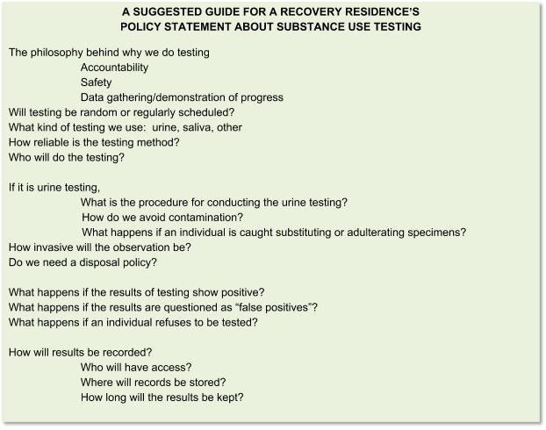

5​.​ ​Dismissing a resident based on a single disputed or unconfirmed drug screening test result is unethical.

When a test is disputed, laboratory confirmation testing is an appropriate and recommended course of action. Resident self- confirmation of drug use following a drug test is acceptable grounds for transfer from the residence.

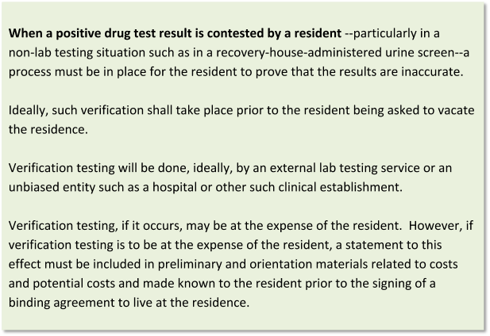

6​. ​Requiring that a resident leave the residential community following a single positive drug test result without offering a safe and available alternative refuge or the opportunity to be placed with a pre-designated caregiver is unethical. Likewise, continuing the safety and support of the residential community following a positive test result is an ethical option.

If a person is found to be under the influence of substances the safety of the residence and individual must both be taken into consideration. Recovery residences are encouraged to create self-directed recovery contingency plans in the event a recurrence occurs. A policy should be in place to protect all concerned, including the larger community (i.e. the police are notified and asked for assistance, the person is taken to a hospital; etc.).

7​.​ ​It is unethical to deliver a person incapable of self-care (i.e., inebriated, suicidal, delusional, experiencing psychotic behaviors, etc.) anywhere the person will not be monitored by a responsible person.

8.​ ​Drug tests provided by allies (court, probation, parole, family and children's services, physicians, employer, IOP/PHP, etc.) are requested to share their results with the recovery residence in a timely manner. Duplicating testing and results is not in the interest of residents and is to be avoided.

When a resident utilizes services in conjunction with a recovery residence, the recovery residence is encouraged to coordinate testing and sharing results when possible. Duplication of confirmation tests is to be avoided. This is commonly referred to as double billing. It is in the best interest of residents to be in active collaboration and communicate with concurrent providers.

9.​ ​​Release of test results can only occur with the resident’s consent and following applicable laws.​ ​It is unethical to release the results of a drug test without permission from the resident except as allowed by law​.

Ideally, drug testing information will be shared among recovery support and service providers ethically, utilizing appropriate confidentiality protocols.

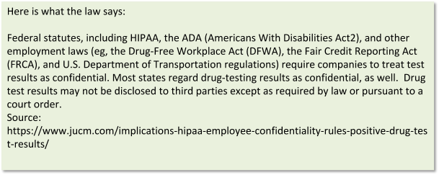

II. Ethical Concerns Regarding Billing to third party payers

Most ethical complaints regarding drug testing involve the billing of third-party payers for confirmation testing. Common unethical (and even sometimes illegal) practices include one or more of the following:

- The owner of the recovery residence has a financial interest in the lab.
- The owner of the recovery residence receives a financial benefit (i.e. kickback, commission, etc,) for sending drug tests to a particular lab.
- The owner of the recovery residence has a financial interest in an IOP/PHP that bills for drug testing.
- The owner of the recovery residence receives a financial benefit (i.e. kickback, commission, etc,) for requiring its residents to participate in a particular IOP/PHP.
- A recovery residence offers “free” or “reduced rate” services to residents that agree to participate in a particular IOP/PHP.
- Adherence to the following ethical guidelines will minimize concerns and complaints regarding billing for drug testing.

10. ​ Financial costs including billing to 3rd party payers and the resident’s obligations related to drug​ testing are disclosed to potential residents and/ their financial supporters.
If insurance is billed financial guarantors must be informed how much they may be responsible for in deductibles, co-pays or out of pocket costs, as well as the amount the insurance will be billed.
It is unethical to withhold information that adds to the cost of a resident’s stay in a recovery residence. Full disclosure of all expectations and costs related to drug testing, substance use and relapse are to be presented to all potential residents prior to their signing any binding agreement.

11. ​Any RR that partners with an IOP or PHP that includes drug testing must disclose to the potential resident, all costs that may be incurred to include cost per test and frequency of testing whether or not billed to a third party.I

12​. ​Duplicate billing for toxicology services between the recovery residence and an IOP partner is unethical.

13. ​It is unethical to use drug testing for profit motives​.

It is not appropriate for recovery residences to use drug testing as a source for revenue generation. frequency of testing must always be based on variables pertinent to the individual ( i.e. drug of choice, detectability windows, etc.). Additionally, It is unethical to base frequency of testing on profitability.

A good litmus test for determining whether the motive is profit-based would be to ask the following: Would the drug testing protocol be the same if there were no financial remuneration for the procedure?

14​. ​Commissions, bonuses, rebates, kickbacks, bribes, remunerations, supplies or anything of value, given directly or indirectly, from a drug testing company is unethical. Engagement in any fee splitting or self-referral arrangement, in any form whatsoever is an ethics violation and may be in violation of the federal Anti-Kickback Statute​.

